WEEK – 1 Date: 13/10/2021

1. **Aim**: WAP to implement Bubble Sort.

**Program:**

l = []

n = int (input("Enter the range: "))

print("Enter the numbers: ")

for i in range(n):

x = int(input())

l.append(x)

def bubble_sort(l):

for i in range(n):

for j in range(i+1,n):

if l[i]>l[j]:

c = l[i]

l[i]=l[j]

l[j]=c

print(l)

bubble_sort(l)

**Output**:

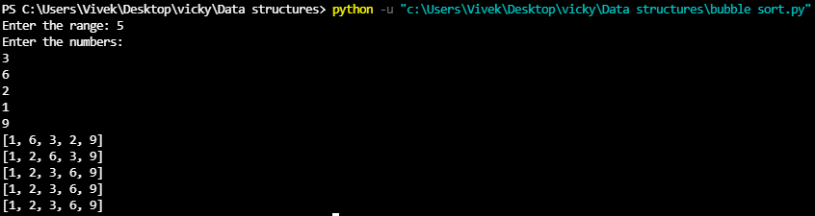

1. **Aim**: WAP to implement Selection Sort

**Program:**

l = []

n = int (input("Enter the range: "))

print("Enter the numbers: ")

for i in range(n):

x = int(input())

l.append(x)

print("The list is:",l)

def selection_sort(l):

for i in range(n):

min = i

for j in range(i+1,n):

if(l[j]<l[min]):

min = j

l[i],l[min]=l[min],l[i]

print(l)

selection_sort(l)

**Output**:

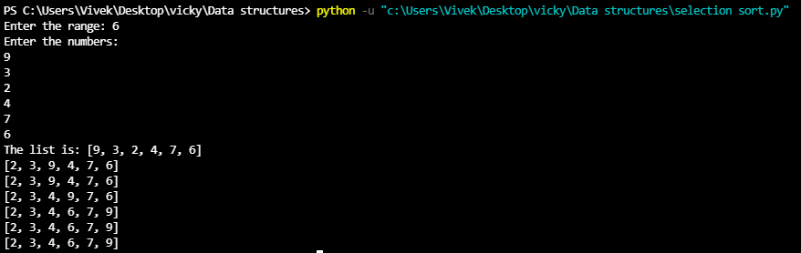

1. **Aim**: Write an application to implement Quick sort

**Program:**

def quick_sort(list,first,last):

if(first<last):

pivot=first

i=first

j=last

while(i<j):

while(list[i]<=list[pivot] and i<j):

i=i+1

while(list[j]>list[pivot]):

j=j-1

if(i<j):

list[i],list[j]=list[j],list[i]

list[pivot],list[j]=list[j],list[pivot]

print(*list)

quick_sort(list,first,j-1)

quick_sort(list,j+1,last)

list=[]

x=int(input("enter the number of elements:"))

for i in range(x):

y=int(input())

list.append(y)

n=len(list)

print(*list)

quick_sort(list,0,n-1)

**Output**:

